# Project0

## Introduction

A Scala CLI (Command Line Interface) application. Data should be parsed from a CSV OR JSON file and persisted to MongoDB OR MySQL. The functionality of the application beyond that is up to you, but here are a few suggestions:

* journal app
* banking app
* business management system
* simple text-based game
* productivity tool
* ...?

## Tech Stack

* Scala 2.13
  + File I/O
  + Collections
* MySQL
* sbt
* Git + GitHub

## Functional Requirements

* Read JSON or CSV files, and store the data contained within those files in a database (really you should have a JDBC that connects to at least 3 tables in your database, and takes user input).
* A CLI where users can interact with the application while it is running.

## Non-Functional Requirements

## Project Idea

* A simple farming sim game where the goal is to pay off a loan by the end of the in-game year.
  + Start off with a watering can, 100 gold, and a certain number of tilled plots.
  + There are 30 days in a season with four seasons in a year.
* Database tables
  + Store with seasonal seed offerings.
  + GrowthRates table that defines the speed of each plant growth, their stages, and when they are in-season.
    - If they are not in-season, they automatically die at the beginning of the day and are removed.
  + Inventory table to track player inventory.
  + BankAccount table that tracks current gold amount and debt owed.
  + Plots table to keep track of the player’s farm plots.
  + A SaleRates table to track how much the player gets for each plant.

## Database Design

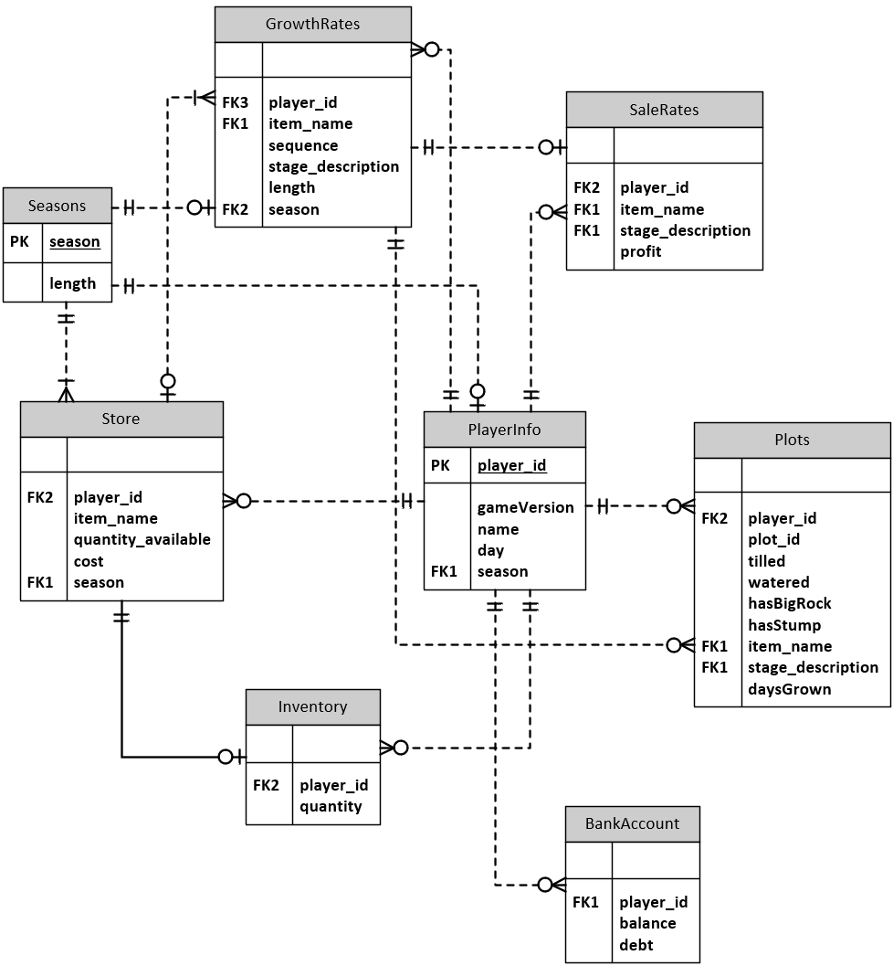

## UML Class Diagram

